**RISK PREDICTION OF STROKE USING DATA MINING CLASSIFICATION TECHNIQUES**

1st Rahatara Ferdousia, 2nd Masum Mohammad Jubayelb, 3rd Asima Akter Chowdhuryc

*a Metropolitan University, Sylhet 3100 Bangladesh.*

[*rahatara@metrouni.edu.bd*](mailto:rahatara@metrouni.edu.bd)

*b Metropolitan University, Sylhet 3100 Bangladesh.*

[*masumjubayel@gmail.com*](mailto:masumjubayel@gmail.com)

*c Metropolitan University, Sylhet 3100 Bangladesh.*

[*chowdhuryasima@gmail.com*](mailto:chowdhuryasima@gmail.com)

**Abstract**

Stroke, a fatal non-communicable disease of any age, kills more people than AIDS, Tuberculosis and Malaria put together in each year. WHO estimated around 6.2 million deaths because of stroke in 2008. As the incidence, prevalence, mortality and disability rates are increasing, overall stroke burden has increased globally. Almost 70% of patients are unaware of their mild stroke, 30% seek medical attention lately and another 30% suffer from recurrent stroke, before seeking attention. Data mining, with its several techniques for classification and regression, plays a leading role in developing an effective model of risk prediction in the context of healthcare. Even though stroke prevention is a complex medical issue, primary prevention could be feasible by using data mining classification techniques that will assess risk factors to predict the likelihood of the disease among mass people. This work is aimed at providing an analysis of different data mining classification algorithms like Naïve Bayes (NB), Decision Tree (DT), Logistic Regression (LR), Random Forest (RF), Support Vector Machine (SVM), etc. on a newly created dataset of 435 patient’s risk factors to find the algorithm with the best accuracy to propose a tool for the end users to check risk prediction.

*Keywords***:** Stroke risk factor, Data mining, Naïve Bayes, Random forest, Risk prediction.

1. **Introduction**

A stroke happens when blood flow is occluded in a part of the brain. The lack of oxygen damages the brain cells that can have potentially disabling effects on the patient. (Services, 2018) When it happens the brain cells divested of oxygen and brain cells begin to die. Then the abilities controlled by that area of the brain such as memory and muscle control are lost. Some strokes affect the muscles used to urinate. There are two types of stroke. They are:

1. Ischemic Stroke
2. Haemorrhagic Stroke

**1. Ischemic Stroke**

An Ischemic stroke is the most common type. It occurs when blood supply is cut off to part of the brain. It accounts for the majority of all strokes. Approximately 85% of strokes are ischemic caused by vascular occlusion.

An ischemic can occur because of lesions caused by atherosclerosis. These lesions may form in the small arteries of the brain and they can block blood flow to the brain. (Services, 2018)

**2. Haemorrhagic Stroke**

A haemorrhagic stroke is a different kind of stroke caused by bleeding in the brain. It happens when a blood vessel breaks and bleeds into the brain. Blood spills into or around the brain and creates swelling and pressure, damages cells and tissue in the brain.

Haemorrhagic stroke is caused by a rupture in a weakened blood vessel in the brain. Haemorrhagic stroke account for about 20% of all strokes. (Services, 2018)

In this thesis paper we will predict the risk of stroke. A man who has not yet stroked, will talk about the possibility of having stroke in the future. It is a more challenging task in healthcare sectors to predict the diseases from the voluminous medical databases. At present, data mining techniques will help us a lot to predict risk. Data mining techniques which includes classifications, clustering, association rule mining for finding risk prediction. In this research work Naïve Bayes Support Vector Machine (SVM) classifier algorithm are used for stroke risk prediction.

The brain is one of the largest and most complex organs in the human body. It is made up of more than 100 billion nerves that communicate in trillions of connections called synapses. [1] It is the central organ of the human nervous system. It controls most of the activities of the body, processing, integrating and coordinating the information it receives from the sense organs and making decisions as to the instructions sent to the rest of the body. Because of an ischemic stroke, brain cells start to die or damage. So, symptoms occur in the body parts (face, eyes, arms, legs etc.) that these brain cells control. There are number of factors which increase the risk of having an ischemic stroke. Some of them are listed below:

* Age and gender
* High blood pressure
* Diabetes
* Ischemic heart diseases
* Smoking
* Family history of stroke
* Stress and depression
* Overweight and obesity
* Abnormal cholesterol levels

1. **Structure:**

The figure1 showed the system architecture of stroke risk prediction. Here the train data set are collected from the reports of some patients from different four hospitals in Sylhet, Bangladesh. The train dataset was pre-processed in pre-processing stage. Then we tested the data set with some algorithms like SVM, ANN, NB, RF, J48, DT, LG etc. and we evaluated the performance accuracy of all those algorithms within 10-Fold Cross Validation and Percentage Split techniques. According the best accuracy, the best algorithm will be chosen for developing the tool. A questionnaire form will be filled up by the user as system input to predict the risk level and to give some tips and suggestions to the end user.

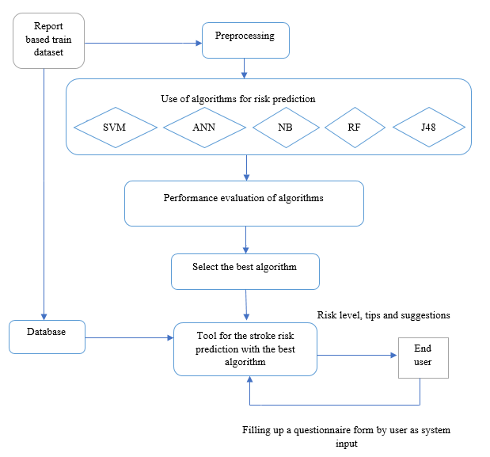

Fig 1: System Architecture for stroke risk prediction

1. **Methodology**
   1. **Prediction_algo**

We analyzed our data set by following the processes are given below in the algorithm 1.

**Input data**: Report based dataset of stroke and non-stroke patient.

**Output data**: Predict the risk level by using proposed tool.

best_performance=0

max_performance= performance (1st algo)

stroke_prediction()

for i=1 to last_algo

if max_performanc < performance (ith algo)

max_performance= performance (ith algo)

i++

end

best_performance= max_performance

Algorithm 1: Algorithm for stroke risk prediction.

* 1. **Naïve Bayes**

Naïve Bayes is a type of classification which follows Bayes theorem and also known as probabilistic classifier method [5]. Naïve Bayes algorithm use to predict the probability of the result or the output for an unseen or unlabeled test input. There are 4 equations are given below those show how the classifier works and we have two classes namely positive (pos) and negative (neg) corresponds to with stroke and without stroke. (Ray, 2017)

P (pos| A) = p (pos|a1) * p (pos|a2) *………p (pos |an) * p(pos ) (1)

P (neg| A) = p (neg|a1) * p (neg|a2) *………p (neg |an) * p(neg ) (2)

P (Ai |pos) $=\frac{Total (P (pos| Ai)) }{Total Pos}$

Here, I starts from 1 and increase until it reaches the last number of our train attributes.

* 1. **Random forest**

Random forest consists of many decision trees is an algorithm which can works for both classification and regression problem. (Donges, 2018) It follows bagged methods. We showed an equation for random forest in equation (3). If there are X= x1,,,,,xn and Y= y1,,,,,,,,yn are two variables then for making decision random forest takes B time replacement and takes the final decision by pooling or voting all the results of those replacement. It predicts the result for an unlabeled or unseen data x $׳.$

$fˆ=\frac{1}{B}\sum_{b=1}^{B}{fb(x)}$ (3)

1. **Experimental Analysis**

In this section, we represented the details of our dataset and the result analysis.

**4.1 Details of the train dataset**

Our train dataset contains the information of 435 persons. We have collected our dataset from four different hospitals of Sylhet, Bangladesh. At first, we preprocessed our data in preprocessing step. In this step, we handled our missing data. For collecting data, we made questionnaire form and then collected the data by filling up those questionnaire forms from the test report of the people who already have stroke and we also collected data from those people who have not stroke but they also have similar problems**.**

Table 1: Description of the train dataset

|  |  |  |
| --- | --- | --- |
|  | Number of Attributes | Number of Instances |
| Report based dataset | 18 | 435 |

In table 1, we gave the description of the dataset and we gave the description of our attributes in table 2. We have collected 435 data and we have 18 attributes. Among 435 data, there are 342 are positive data and 93 are negative data. Class attribute has two variables those are stroke and non-stroke.

Table 2: Description of attribute

|  |  |
| --- | --- |
| Attributes | Values |
| Age | 1.25-34, 2.35-44, 3.45-54,4.55-65,5.65< |
| Gender | 1. Male 2. Female |
| SBP | 1.120>, 2.120-139, 3. 140-160, 4.160< |
| DBP | 1.180>, 2.80-95, 3.95< |
| Diabetes | 1. No, 2. Yes |
| Ischemic Heart Disease | 1. No, 2. Yes |
| Family History of stroke | 1. No, 2. Yes |
| Alcoholic | 1. No, 2. Yes |
| Less Physically Active | 1. No, 2. Yes |
| Smoking | 1. No, 2. Yes |
| Stress and depression | 1. No, 2. Yes |
| TG↑ | 1. No, 2. Yes |
| LDL↑ | 1. No, 2. Yes |
| HDL↓ | 1. No, 2. Yes |
| Situated Fat↑ | 1. No, 2. Yes |
| Fibre↓ | 1. No, 2. Yes |
| CKD-Kidney | 1. No, 2. Yes |
| Class Attribute | 1. Stroke, 2. Non-stroke |

**4.2 Details of the result analysis**

In our work, we wanted to provide an analysis of different data mining classification algorithms like SVM (Support Vector Machine), NB (Naïve Bayes), RF (Random Forest), J48, ANN (Artificial Neural Network ), LR (Logistic Regression), RT (Random Tree) etc. We applied those classification algorithms on our dataset and we evaluated the performance accuracy of each classification algorithms through both 10-Fold Cross Validation and percentage split evaluation techniques. That’s also shown in table 3.

|  |  |  |  |  |  |  |  |  |  |  |  |  |  |  |
| --- | --- | --- | --- | --- | --- | --- | --- | --- | --- | --- | --- | --- | --- | --- |
| Evaluation Metrics | 10- Fold Cross Validation | | | | | | | Percentage Split (80:20) | | | | | | |
| NB | SVM | LG | J48 | RT | RF | ANN | NB | SVM | LG | J48 | RT | RF | ANN |
| Total number of the instance | 435 | 435 | 435 | 435 | 435 | 435 | 435 | 87 | 87 | 87 | 87 | 87 | 87 | 87 |
| Correctly Classified  Instance | 348 | 342 | 351 | 355 | 341 | 361 | 356 | 70 | 67 | 68 | 68 | 67 | 66 | 68 |
| 80% | 78.62% | 80.69% | 81.61% | 78.39% | 82.99% | 81.84% | 80.46% | 77.01% | 78.16% | 78.16% | 77.01% | 75.86% | 78.16% |
| Incorrectly classified instance | 87 | 93 | 84 | 80 | 94 | 74 | 79 | 17 | 20 | 19 | 19 | 20 | 21 | 19 |
| 20% | 21.38% | 19.31% | 18.39% | 21.61% | 17.01% | 18.16% | 19.54% | 22.99% | 21.84% | 21.84% | 22.99% | 24.13% | 21.84% |

Table 3: Comparison of evaluation metrics using 10fold cross validation and percentage split (80:20)

We know Random Tree algorithm is a very famous and very well-known algorithm for classification but in this work, it gives the lowest performance accuracy. It has been correctly classified only 78.39% in cross validation evaluation techniques where Random forest algorithm has been correctly classified 82.99% and Naïve Bayes has been correctly classified 80%. In percentage split evaluation, NB has been correctly classified 80.46% where Random forest has been correctly classified 75.86%.

1. **Proposed Tool to the End User**

As we wanted to provide a tool for our end user to help them to know the probability of having stroke. In this modern era, every educated person knows the use of websites and web technology has become a great tool for everyone. So, we chose web technology to give an instant help to people all over the world for predicting the probability of having stroke. With the help of this website people can predict his/her risk level of stroke from anywhere of the world. This website also gives some helpful suggestions and healthy tips to the end user. Those helpful suggestions and tips can help the people who have not stroke yet to remove or decrease the probability of being stroke. This is a very easy, understandable and simple website. So, the user can use it very easily and quickly. In figure 3, we showed a demo homepage of our proposed tool.

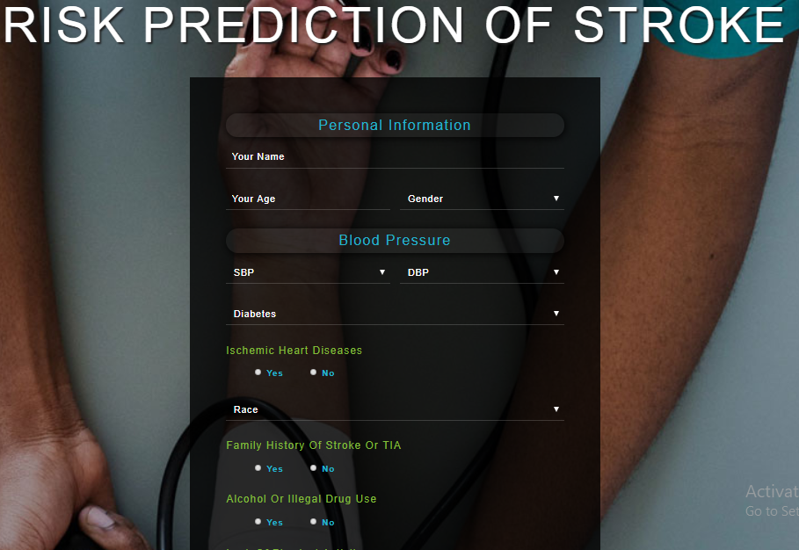

Fig. 2. Proposed tool for the end user

1. **Conclusion**
2. **References**